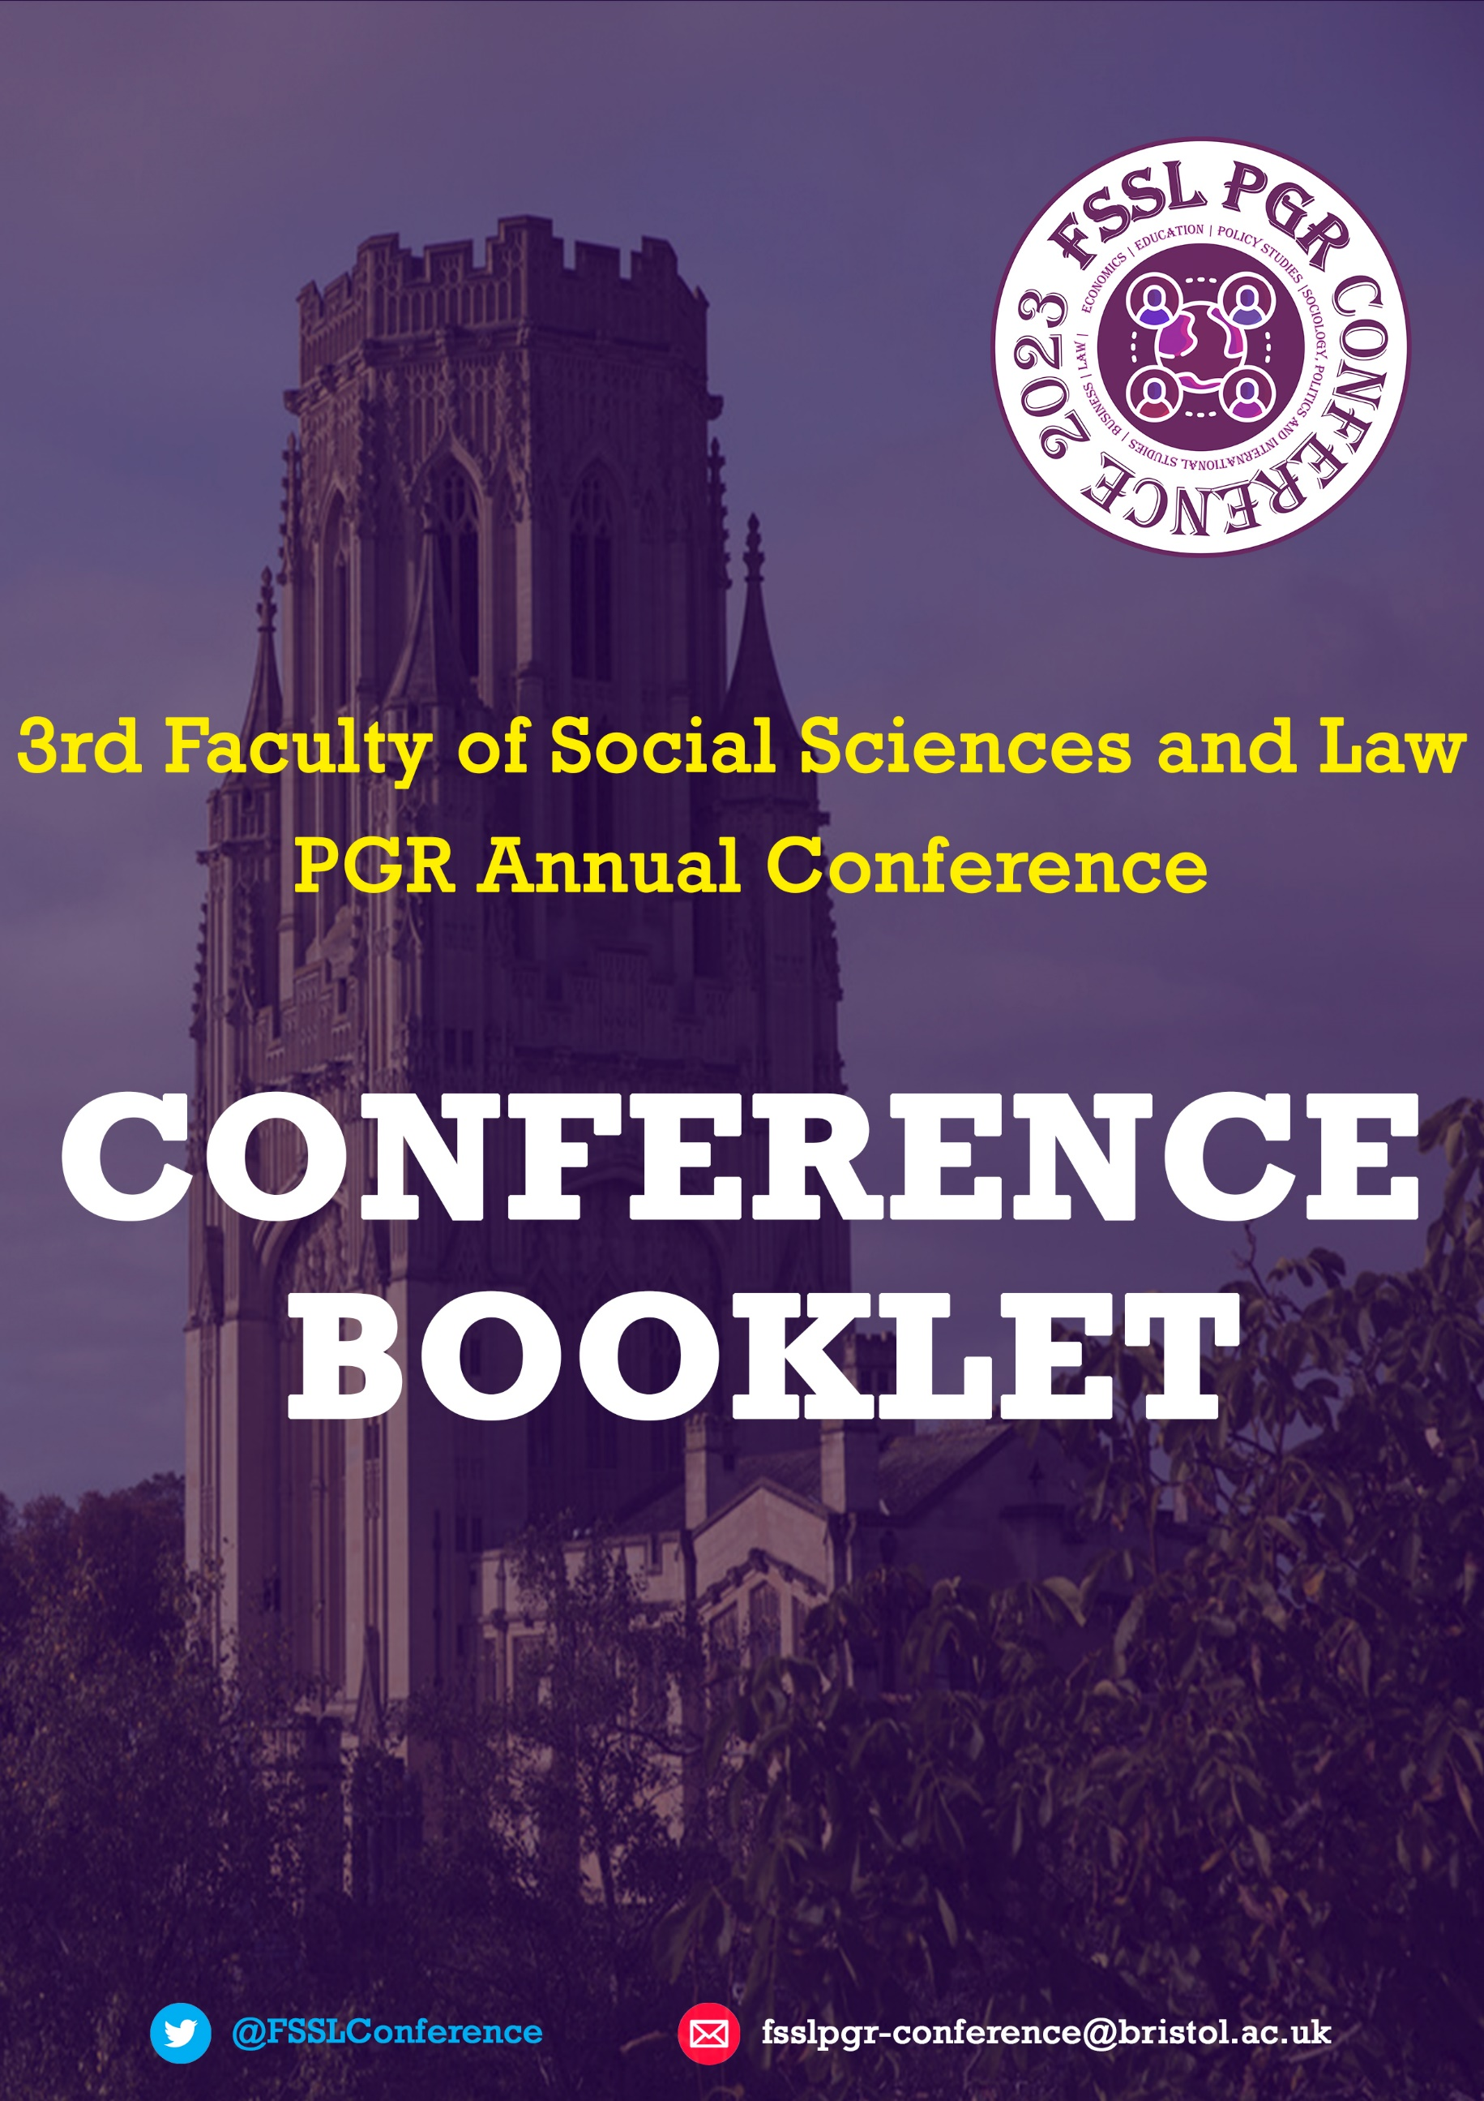

Welcome Note
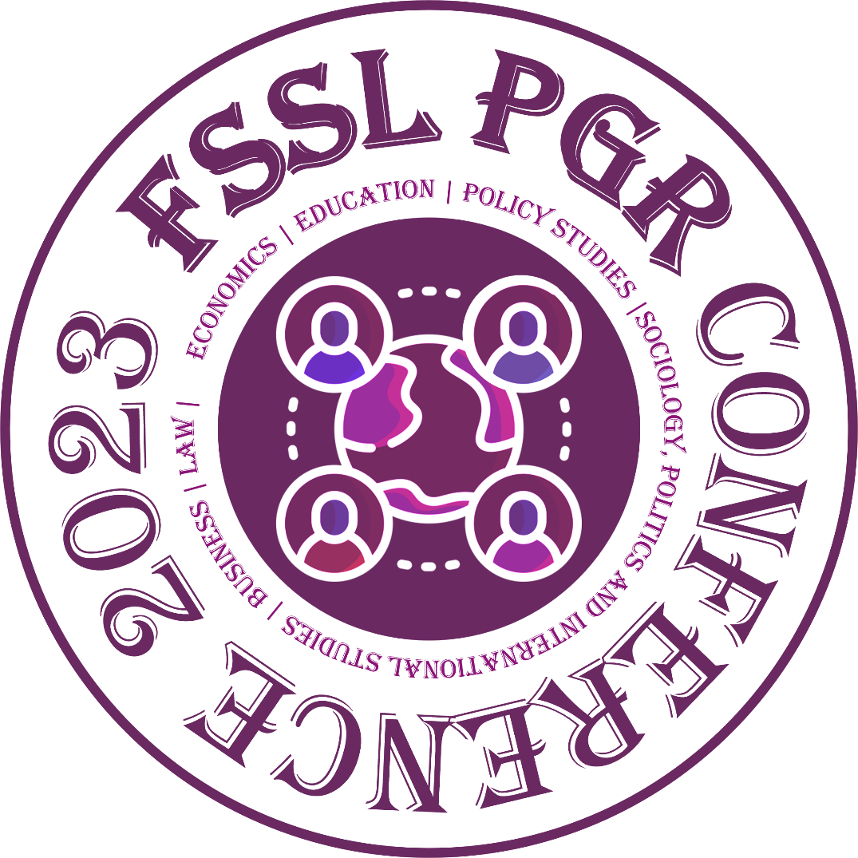
Welcome to the 3rd Faculty of Social Sciences and Law Postgraduate Research conference at the University of Bristol!
This year’s conference is about Our Common Future. We are excited to have students from across the six schools in our faculty present their research on topics ranging from sustainability and equity and equality issues to contemplating what the future might look like for indigenous communities, school-aged children and elderly people. The purpose of this conference is to provide a safe space for PGR students to present their research, exchange ideas in a supportive and collegial environment and facilitate conversations across disciplinary and interdisciplinary fields.
We would like to thank the organising committee for their year-long works in putting this conference together! Everyone on the committee contributed fantastic ideas and helped to shape the conference to be a unique event to showcase research and support the development of a PGR community.
We hope you all enjoy this year’s faculty PGR conference!
By Antonia Voigt and Deepti R Bhat
Greeting from all conference committee members:
(Listed below in alphabetical order)
Antonia Voigt
Colin Yang
Deepti R Bhat
Margaret Abazie-Humphrey
Ruizhe Zhang
Shan Lu
Shang Wu
Sultan Alotaibi
Wing-Fu Lai
Yirong Han

Contents
About the Conference 4
Conference Program 6
Parallel Sessions 7
Special Sessions 10
Abstracts Of Presentations 11
Sustainability Practices At The Conference 23
Sponsor/Partner Acknowledgements 24
Guidelines for Attendees 24

About the Conference
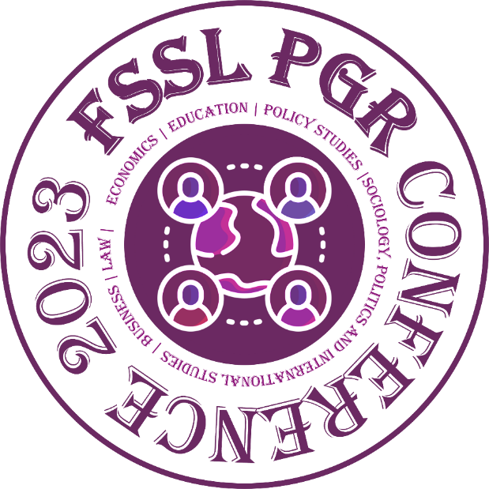
Welcome to the 3rd annual Social Sciences and Law Faculty PGR Research Conference!
The PGR Research Conference arose out of the desire of post-graduate research (PGR) students in the Faculty, many pursuing PhDs, to meet and engage intellectually with peers from other schools and to create a Faculty-wide intellectual community. For several years, school reps, the Faculty Rep, and I, as Faculty PGR Director, had discussed that PGRs too frequently felt corralled, institutionally and intellectually, in disciplinary, school and/or departmental ‘siloes’. While disciplines, schools and departments are crucial, we wanted to encourage, and create a space for, more cross-disciplinary and cross-school engagement, fostering vibrant intellectual dialogue about the substantive topics, theoretical approaches, and methodologies that we know our PGRs share across what are, after all, largely artificial academic boundaries. A Faculty-wide research conference, organized by our students themselves, seemed a good mechanism to explore how we might accomplish this. Additionally, it would provide career and professional development opportunities in various dimensions of conference organizing.
The pandemic hit while we were planning the inaugural 2021-22 conference. Raffaello Rossi, then the Faculty Rep (now a lecturer in the Business School), led the first conference organizing team. They swiftly moved the conference online, creating a wonderful digital event held during Welcome Week. It served successfully to inaugurate cross-Faculty intellectual conversations amongst PGRs across all our schools. It also allowed us to meet and to welcome new PGRs who, given the pandemic, began their PGR journeys without any in-person teaching, supervision, or peer support. We think it was a success on both counts. The team organizing the 2nd conference in 2022-23 was led by Uygar Baspehlivan, then a second-year PhD student in SPAIS. As we slowly emerged from the pandemic, and while many students remained overseas or outside of Bristol, Uygar and his team successfully hybridized the 2nd conference, which was held partly on campus but with many participants joining online. Again held during Welcome Week, two successful days of conferencing and socializing helped to sustain the growing sense of Faculty-wide intellectual PGR community.
Antonia Voigt, the incoming Faculty Rep for 2023-24 and a third-year PhD student from Education, has been leading this year’s superb conference organizing team. The team have successfully applied for funding for a series of pre-conference training workshops – on such topics as delivering presentations and networking at conferences – which you may have attended. This year’s conference features, for the first time, skills training and workshops on abstract writing and ethics as a lifelong approach to research. In addition, supported through funding from Bristol Doctoral College, we are proud to have put together a cross-disciplinary panel to discuss and showcase how research happening across the University of Bristol contributes to improving our common future and to our understanding of sustainability.
We are proud of and very pleased by the development of and expansion across these annual Faculty PGR Research Conferences. We anticipate that the third iteration will be even more intellectually stimulating and exciting and we welcome all PGRs across the Faculty to attend!

By Professor Jutta Weldes,
FSSL PGR Director (until August 2023)

CONFERENCE PROGRAMME

DAY 1, 11th October |  | Room
8:30-9:00 | Registration | Outside WMB 1.11 OCC
9:00-9:45 | Opening Speech | WMB 1.11 OCC
10:00-11:00 | Parallel Session 1
 | 1.1 Challenging Perceptions and Understandings | WMB G38
 | 1.2 Markets in Actions | WMB L102
 | 1.3 Supporting the New Generations | WMB L110
11:15-13:15 | Special Panel Discussion – Cross-Disciplinary Exploration on Our Common Future (funded by BDC)  Run by: Colin Yang and Antonia Voigt  Speakers: Guy Howard, Terra Sprague, Stuart Cooper, Josie McLellan | QUEENS BLDG 1.07
13:15-14:15 | Lunch with Bristol University Press | QUEENS BLDG (TBC)
14:15-15:30 | Parallel Session 2
 | 2.1. Global Social Progress | WMB 3.33
 | 2.2. Promoting Equity and Equality | WMB 5.68
 | 2.3. Global Citizenship for All | WMB 3.23

Day 2, 12th October |  | Room
8:30-9:00 | Registration | Outside  35 BSQ HWB 1.20  35 BSQ HWB 4.02
9:00-10:00 | Parallel Session 3
 | 3.1. Conceptualising and Designing Research | 35 BSQ HWB 1.20
 | 3.2. Rethinking the Roles of Higher Education | 35 BSQ HWB 4.02
10:15-11:00 | Ethics Discussion – Why and how does it matter?  Run by: Dr Anita Mangan, Liam McKervey, and Marc Moyce | 35 BSQ 4.05/4.06
11:15-12:15 | Session 4
 | 4.1. Improving Systems and Online Spaces | 35 BSQ HWB 4.08
12:15-13:15 | Lunch with Bristol University Press | 35 BSQ
13:15-14:00 | Social Event/Networking Activities | WOODLAND RD 10 G4/5
14:00-15:30 | Abstract Writing Workshop – What makes a good abstract?  Run by: Prof Leon Tikly, School of Education | WOODLAND RD 10 G4/5

Parallel Sessions

Session 1.1. Challenging Perceptions and Understanding (Room: WMB G38)
CHAIR: Annaliese Wren
- Helena Xiao, Law School – How and why did domestic violence become perceived as a problem of law in China and its official reaction?
- Jungje Yoo, Business School – The impact of social justice, utilitarian and social acceptance on intention to use autonomous vehicles
- Annaliese Wren, Law School – UK copyright law and creative individuals

Session 1.2. Markets in Action (WMB L102)
CHAIR: Billy Greville
- Lisa Waddell, School of Policy Studies – Family socialisation and labour markets
- Lan Nguyen, Business School – Value alignment and well-being in mission-driven organizations
- Billy Greville, Business School – Easy-to-use digital investing platforms and consumer welfare

Session 1.3. Supporting the New Generations (WMB L110)
CHAIR: Jasmine Ibayeva
- Florie Schmits, School for Policy Studies – Improving the lives of siblings in care – a pilot study
- Qiaoling Ye, English Language and Applied Linguistics – The eye-tracking study of contrasting tenses and aspects in English: The role of working memory
- Jasmine Ibayeva, School of Education – Teacher literacy of writing assessment: Teachers’ ability to use IELTS Writing Task 2 criteria in formative assessment of students’ Task 2 compositions in Azerbaijan

Session 2.1. Global Social Progress (WMB 3.33)
CHAIR: Deepti R Bhat
- Oby Bridget Azubuike, School of Education – Investigating factors influencing secondary school enrolment in Nigeria through multilevel modelling
- Lawrence Osei Owusu, School of Policy Studies – Understanding the role of citizens’ assemblies in sustainable cities planning: Concepts and approaches
- Ashley Huang, Law School – Sino-African partnerships under the Belt and Road Initiative
- Vy-Liam Ng, Law School – Pursuing peace for the Rohingya people of Myanmar: Theorising the duty to protect in the context of international law and the protection of stateless groups from Genocide

Session 2.2. Promoting Equity and Equality (WMB 5.68)
CHAIR: Afiya France
- Arpeeta Mizan, Law School – Narratives of Legal Consciousness: What is law for Bangladeshi people?
- Eliza Hostin Silva, Business School – Late-stage capitalism, inequalities and the climate emergency
- Afiya France, Law School – Promoting capacity rights of people with mental disabilities: Comparing the genealogies of contemporary capacity law in Ireland and Trinidad and Tobago

Session 2.3. Global Citizenship for All (WMB 3.23)
CHAIR: Ruizhe Zhang
- Sarah Holey, Business School – People and mining: Indigenous communities and democratic corporate governance
- Hilda Akinyi Owii, School for Policy Studies – Understanding the meanings and anticipation of long-term care among older adults and their families in an urban poor context in Nairobi, Kenya
- Yifei Sun, School of Sociology, Politics and International Studies – Home education and extra-curricular activities in China’s urban regions
- Stefan Zylinski, Global Political Economy Interdisciplinary: School of Sociology, Politics and International Studies, School for Policy Studies and School of Geographical Sciences – Capitalism, finance & climate crisis: How are different types of financial systems contributing to the climate crisis?

Session 3.1. Conceptualising and Designing Research (35 BSQ HWB 1.20)
CHAIR: Pen Williams
- Jizhao Niu, School for Policy Studies – Developing an index for assessing adherence to the traditional Chinese diet by using the Delphi method
- Charlotte Friel, School for Policy Studies – Why my social worker comes to see me: voices of primary-aged children and their social workers about communication and understanding
- Pen Williams, School of Education – Conceptualising research through the exploration of key terms and ideas

Session 3.2. Rethinking the Roles of Higher Education (35 BSQ HWB 4.02)
CHAIR: Will Hunter
- Paul Stevens, School of Sociology, Politics and International Studies – Academic book publishing and its relationship with various other stakeholders in higher education
- Yiyun Zhang, School of Education – Curriculum assessment of the professional Postgraduate Degree (PGD) in Mainland China
- Will Hunter, Business School – The End of the University (as we know it)

Session 4.1. Improving Systems and Online Spaces (35 BSQ HWB 4.08)
CHAIR: Aynur Dadashova Mammadova and Adrianna Jezierska
- Anran Xiongchen, School of Education – Effectiveness and pragmatics of university career support and guidance
- Aynur Dadashova Mammadova, School of Education – The role of school self-evaluations to improve educational quality
- Matt Bassett, School of Sociology, Politics and International Studies – Gender identification shaped by and through the online contexts
- Adrianna Jezierska, Business School – Impact of climate-diet discourse on social media on the everyday practice of food consumption

Special Sessions
Cross-Disciplinary Panel Discussion
This engaging session will bring together from working at university of Bristol who will draw on their expertise. This session will focus on how research conducted at Bristol contributes to the rebalancing of economic, social and environmental aspects of human developments.
Run by: Colin Yang and Antonia Voigt
Abstract Writing Workshop
Professor Leon Tikly will lead this session on writing impactful and appealing abstracts using an interactive approach. This session will provide you with tools and strategies to articulate and write a great abstract!
Networking Lunch
On both days of the conference, we invite you to have lunch with the fellow presenters and attendees. We are delighted to also have Bristol University Press at the lunch both days. They will have displays of relevant books and journals for you to buy at a discount and offer other free material.
Ethics Discussion
Dr Anita Mangan and her colleagues from the FSSL Ethics office will lead a collaborative session on what ethics means for PhD researchers and how ethics can go beyond University procedures to become a lifelong approach.

Abstracts of Presentations

Impact of climate-diet discourse on social media on the everyday practice of food consumption
Adrianna Jezierska, Business School
The environmental issues of food production and consumption have intensified the food discourse across the globe. The shift of society towards sustainable food futures requires a collective approach to challenge meat and dairy-based diets in the everyday practice of eating.
Situated within contemporary veganism, organisations theory and collective views, this PhD project examines involvement in the climate-diet discourse on social media. Social media platforms have become critical venues for a wide spectrum of influence and engagement, from politics to activism. A few studies have documented a climate-diet discourse. However, they focus on a specific vegan-related campaign or anchor a publication of scientific reports, providing little information as to what extent and how this discourse can effectively contribute to the climate change agenda.
This PhD project will address the question above twofold. First, we will consider computational research methods, such as social media and visual network analysis; second, we will use qualitative research methods, including interviews. This project will unveil the intimate connection between food discussions on social media and the everyday practice of food consumption. Such enquiry can potentially inform the field of management by contributing to the research on collaborative views and social media agents who facilitate social change.

Promoting capacity rights of people with mental disabilities: Comparing the genealogies of contemporary capacity laws in Ireland and Trinidad and Tobago
Afiya France, Law School
The lives of people with mental disabilities (PWMD), including intellectual and psychiatric disabilities, are heavily impacted by legal frameworks that determine whether they are considered able to make choices about their own lives known as ‘mental capacity’ laws (“capacity laws”). Though Ireland has sought to reform its capacity laws to reflect new international disability rights norms, Trinidad and Tobago (“TT”) has un-developed capacity laws. This research uses Foucault inspired genealogy as a methodological tool to discern the historical web of discursive and non-discursive practices that define the limits of present-day capacity laws in each country. It seeks to understand how, and through what power relays, certain practices have emerged and gained legislative dominance in each country.
In uncovering histories of each country’s current legislative approach, this research reveals the present as historically contingent, and the future as open and indeterminate. It takes a critical approach to unearth complex understanding of the trajectory towards Ireland’s more progressive capacity laws- the participation of both hegemonic and subjugated discourses in producing contemporary progressive practices. Through cross-cultural comparison of Ireland’s and TT’s genealogies, this research reveals nuanced understanding of pathways to capacity law reform which could be activated to improve the lives of PWMD.

UK copyright law and creative individuals
Annaliese Wren, Law School
The various tests, lack of a legal definition, and muddled position of UK copyright law demonstrates that copyright law is in no better position now, in terms of clarity on a legal definition of an artistic work, than when the Copyright Act of 1911 was drafted. The lack of a cohesive statutory definition has led to confusion within the courts. My research aims to show that UK copyright law risks marginalising creative individuals who do not fit within pre-assumed boxes of what the law views an artistic work to be. As a result, the CDPA, alongside its judicial interpretations, is failing the modern artist. My research intends to demonstrate this is due, in part, to how UK copyright law views art as an economic commodity. This has led to inequitable treatment of artists, notably in comparison to copyright protection afforded to other artforms (i.e., music).
To overcome current problems posed by the lack of a consistent definition of ‘artistic work’, UK copyright must adapt to accommodate emerging artforms and protect the artists who create them. This paper argues a starting point for such change is for UK copyright law to incorporate an adaptation for contemporary artistic works which is needed in today’s modern artistic environment.

Effectiveness and pragmatics of university career support and guidance
Anran Xiongchen, School of Education
In recent years, extracurricular activity (CA) participation has become increasingly widespread in China. Students participate in ECAs to develop ‘employer-preferred’ traits and, therefore, to signal their employability to potential employers. However, scholars found that although students have a comparatively clear motivation to do ECAs, they seem not to have a clear understanding of their choice of activities. Instead, many students were found jumping between different activities and constantly doubting their choices of the engaged activity.
In this regard, the role of higher educational institutions (HEIs) is noteworthy. In fact, HEI is believed to have the most potential to respond specifically based on varying demands; it plays a crucial role in helping students access employment opportunities and providing navigation to reduce the costs of trial and error. This is particularly crucial for students from underprivileged backgrounds, who have a lower capacity for trial and error but a higher demand for employment prospects. However, evidence on the effectiveness and pragmatics of university career support and guidance is paucity in China. Therefore, this study focuses predominantly on campus-provided career services to emphasise the role of Chinese higher education institutions in providing graduates with career advice and assistance.

Narratives of Legal Consciousness: What is law for Bangladeshi people?
Arpeeta Mizan, Law School
My doctoral project explores what ordinary people understand by the word ‘law’, and how they approach and experience law in a post-colonial South Asian society that is deeply influenced by religious formalism. In The Common Place of Law, Ewick and Silbey designed their project ‘to capture a picture of legality unmoored from official legal setting’.1 The ‘law’ in their project emanates from state laws and formal rules.2 In talking about non-state legalities, Ewick and Silbey still pertained to positivist notions of law such as land, ownership, disputes, as exemplified by chairs in a shovelled parking spot. 3 My project asks whether people’s idea of law in postcolonial societies is different and if so, why? In my PhD dissertation, I argue why and how the typologies of legal consciousness as understood and applied by global North/ Western scholars cannot capture the lived experience of law in Bangladeshi society and hence needs to be decolonised.
For the workshop I wish to present a chapter of my PhD that focuses on the meanings of law as perceived in everyday life of a Bangladeshi metropole. This chapter will analyse how Bangladeshi people’s throughts and actions around law are guided by religion and influenced by their identity; resulting in a gap between people’s idea of law and the state’s idea of law; and consequently, and to appreciate what ordinary Bangladeshi people may understand to be ‘law’. This will be done by analysing the field data collected through qualitative interviews with 50 adult citizens of Bangladesh. I have done a purposeful sampling and collected my research data from participants who display compliance with religious norms The chapter will further discuss whether the identity school of legal consciousness as explained by Chua and Engel4 constructs the basis of people’s legality through alternative norms of religion, and resultantly their decisions of conformity and resistance.

Sino-African partnerships under Belt and Road Initiative (BRI)
Ashley Huang, Law School
The Sino-African interaction has a long history, and China values its partnership with Africa as an important part of its independent foreign policy of peace in the 21st century. China aims to enhance all-round cooperation with Africa in the political, economic, educational, scientific, cultural, health, social, peace and security fields. Considering that both China and African Union (AU) have released the Belt and Road Initiative (BRI) and the African Continental Free Trade Area (AfCFTA) respectively as their own development strategies in the 21st century, this paper will explore the mutual achievability of these two development initiatives and the Sino-African partnerships, under the framework of the BRI and the AfCFTA, especially in the fields of infrastructure, trade, financing, and investment. This research will be an interdisciplinary study, primarily drawing on international economic law, international relations, international political economy and development studies. The secondary resources covering different disciplines will be collected, analysed, and evaluated. With more in-depth research, this study will be able to offer a unique contribution to the scholarship on Sino-African development and partnerships, and the broader disciplines of international economic law and international relations through its investigation and discussion of the BRI and the AfCFTA.

The role of school self-evaluations to improve educational quality
Aynur Dadashova Mammadova, School of Education
This doctoral research aims to explore key stakeholders’ perceptions of the nature and purpose of School Self-Evaluation (SSE) in improving educational quality and examine existing external and internal evaluation policies and practices, as well as the potential strengths and weaknesses of SSE to support school development planning and improvement in secondary schools in Azerbaijan. A mixed-method sequential research design will be employed to conduct research in three purposively selected secondary schools in Azerbaijan. The study will collect quantitative data first and qualitative data later. Data collection will start with a survey, of which the results will partly inform the development of an interview guide. In addition to the survey’s input, the interview guide’s content will be formed based on the relevant literature on SSE. For the analysis process, the thematic analysis technique will be used for qualitative data analysis, and the researcher will use NVivo software as a technological aid. Quantitative data will be analysed using SPSS. From the policymakers’ perspective, the results of this study can guide school administrators and teachers to understand the potential feasibility and benefits of selfevaluation in Azerbaijani schools and are expected to be useful in Azerbaijan secondary schools within the scope of the State Strategy for the Development of Education in the Republic of Azerbaijan.

Easy-to-use digital investing platforms and consumer welfare
Billy Greville, Business School
In recent times, the financial world has catapulted into the mass market, providing consumers unprecedented access to a growing variety of investing products, spanning stock markets to cryptocurrency markets. Consequently, the number of consumers regularly buying and selling financial instruments has rapidly increased, in the form of “D.I.Y” investing. This uptake however is potentially being driven by a more speculative kind of investing, where riskier pursuits resemble that of gambling. Given this is a recent phenomenon not enough is currently known, with little research existing on the topic and the implications on consumer welfare. Furthermore, despite becoming a burgeoning consumption activity, consumer investing has seen limited interest within consumer research. Consequently, this interdisciplinary PhD aims to address these research gaps, applying a Consumer Culture Theory (CCT) lens to explore the consumer investing ecosystem; specifically focusing on two recent developments associated with the popularity of both a new wave of easy-to-use digital investing platforms and online consumer investing communities. Main research contributions: Firstly, to inform UK regulation with policy-relevant research grounded within theories relating to marketplace ideologies, consumer collectives and persuasive design. Secondly, to advance CCT knowledge by studying this novel type of consumer group and context. Finally, to illustrate how researching complex contexts such as financial markets can greatly benefit from CCT approaches.

Why my social worker comes to see me: voices of primary aged children and their social workers about communication and understanding
Charlotte Friel, School for Policy Studies
Existing research has demonstrated that social workers can feel under-confident and unsupported in communication skills. It is important that children who are supported by social workers are heard and have clarity about their own lives, however research shows that this is not always the case.
Whilst research has been undertaken with children and young people about their experiences of communication during social work interventions, this is predominantly with older children. Using a children’s rights approach this research intends to explore how communication is experienced by younger children and social workers.
The presentation will discuss a mixed methods systematic review (MMSR) that is being undertaken to examine what is already known about the views and experiences of children and social workers around communication. The findings aim to provide evidence that could impact policy and practice, but will also help inform the objectives, research questions and methodologies for the other integrated thesis studies.
The design and results of the MMSR will be the focus of the presentation. The challenges associated with synthesizing qualitative, quantitative and mixed methods data will be discussed.

Late-Stage Capitalisms, Inequalities and the Climate Emergency
Eliza Hostin Silva, Business School
Late-stage capitalism has produced interwoven crises that put increasing pressure on social and environmental systems, exacerbating inequalities and the climate emergency. The scientific community has been warning about the impacts of these pressures and calling for fundamental transformations in the economy and business that prioritise well-being.
Solidarity Economy enterprises (SEE), non-capitalist organisations that serve the needs of communities, offer a counter-narrative to business as usual, showing that it is possible to thrive while caring for people and the planet. That raises this research question: How do Solidarity Economy enterprises contribute to the resilience of communities in the face of crises, and what factors make these enterprises resilient models?
Inspired by the diverse economies approach, by Gibson-Graham, my research aims to inventory and describe the practices of SEE, looking for insights into i) how surplus is distributed and therefore, how wealth is distributed in society; ii) how environmental impacts are considered in decision-making and how accountable organisations are for planetary regeneration; iii) how relational practices are structured and how committed they are with their communities. Additionally, giving visibility to these practices helps to decentralise the capitalist narrative and allows space for new imaginaries.

Improving the lives of siblings in care. A pilot study
Florie Schmits, School for Policy Studies
A recent report from the Children’s Commissioner England showed that 37% of children with a sibling are separated from their sibling when placed in care. In order to improve the lives of siblings in care, this study will examine decision-making and reasons for sibling separation in care in England from the perspective of a local authority.
The main study will use a mixed-methods design: a quantitative analysis of children’s social work case documentation and interviews with social workers, to examine sibling placement decision-making. To determine the feasibility of the main study, and suitability of methods and interview questions, a pilot study is being conducted as the first phase of this research.
This presentation will focus on the results of the pilot study and the insights that were gained from examining local authorities’ case files and case management data on their appropriateness for answering questions about decision-making and reasons for separating siblings in care. In addition, the presentation will discuss the value of a pilot study when planning to analyse large amounts of sensitive data and the learnings from this pilot study in relation to the main (follow-up) study.

How and Why Did Domestic Violence Become Perceived as a Problem of Law in China and its Official Reaction
Helena Xiao, Law School
This Chapter explores the development of the legal response system to domestic violence in China in a social, cultural and political context. I argue that although gender approaches have been adopted in embedding anti-domestic violence into the law system in different historical stages since modern China, family stability, rather than gender equality, has always been the core subject of the legal response system to domestic violence. This Chapter started with summarising numerous types of domestic violence in China and the controversy concerning the definition of ‘domestic violence. Then it explores two high-profile domestic violence cases that have provoked public outrage in China while turning domestic violence into a problem that needs to be addressed in law. These two cases also represent two main issues concerning the governance of domestic violence in China.

Understanding the meanings and anticipation of long term care among older adults and their families in an urban poor context in Nairobi, Kenya
Hilda Akinyi Owii, School for Policy Studies
Many older Africans, age 60 years and above, alive today are coping with one or more chronic condition and will spend some years living with functional impairments that could introduce a need for long term care in future. Older adults living in urban slums in Africa often face unique everyday challenges that predispose them to chronic and other health conditions. The main aim of my proposed study is to explore whether and how slum dwelling older adults, who have chronic illness but are not yet care dependent, and their families anticipate long term care.
I will seek to first understand individual and collective conceptions of long term care -to serve as a framework for contextualizing and exploring anticipation. Drawing on semi-structured in-depth interviews and focus group discussions with older adults, their families and community members -the proposed study will explore how the knowledge, social realities, material and other drivers in the slum, interweave to shape understandings and anticipation of long term care. Study findings could contribute to broadening and diversifying understanding on LTC through generating grounded Africa-centred conceptualizations and perspectives but also inspire thinking about alternative policies that are responsive to slum dwellers aspirations for care futures.

Teacher literacy of writing assessment: Teachers’ ability to use IELTS Writing Task 2 criteria in formative assessment of students’ Task 2 compositions in Azerbaijan
Jasmine Ibayeva, School of Education
Teacher assessment literacy of writing is one of the essential factors influencing students’ writing performances. To what extent can teachers evaluate their students’ essays when preparing them to test - IELTS (International English Language Testing System)?
The current study investigates teachers’ ability to provide students with written formative feedback in the IELTS test preparation institutions. It also intends to find to what extent teachers can use IELTS assessment criteria when responding to students’ compositions.
Many researchers have studied teachers’ assessment literacy in writing; however, very few have looked into teachers’ ability to afford written feedback and use IELTS criteria when responding to their students’ IELTS Task 2 compositions.
This study intends to employ a mixed-methods methodology. It will derive quantitative data from 50 samples’ written feedback on students’ IELTS Task 2 compositions. Each participant will provide 10 essays with their comments on. The study will conduct interviews to collect qualitative data. The interviewees will consist of 20 volunteer samples and show their feelings about responding to students’ writing. The study will analyze quantitative and qualitative data separately. Following this, it will apply a triangulation approach to find the extent to which teachers’ views about writing assessment and their writing assessment performance are convergent.

Developing an index for assessing adherence to the traditional Chinese diet by using the Delphi method
Jizhao Niu, School for Policy Studies
Traditional diets are being widely promoted to reduce the risk of non-communicable diseases, and the exploration of the traditional Chinese diet is therefore important considering the high prevalence of disease in China. This study plans to develop an index by using the Delphi method, that measures adherence to the traditional Chinese diet which will help to assess the association between the adherence to traditional Chinese diet and health outcomes in the future. Additionally, due to significant regional variations in diet across China, this study will explore whether the traditional Chinese diet differs across the country, by exploring the traditional regional diets of five regions (East, West, South, North, and Central), in addition to the whole diet. Delphi is a method that invites experts to discuss a specific topic through several rounds of questionnaires until a consensus is established. 50 experts in the nutrition field from five regions of China were invited to participate in a three-round Delphi study to examine the food groups, specific foods and food-related habits that would constitute a TCD index, via the Jisc online platform. Participants received a questionnaire every five weeks over the 15 weeks. They were asked to complete a total of three questionnaires which is called 'three rounds'. In the first round, participants were required to complete a questionnaire that ask their perspectives about food groups and frequency of consumption of food groups in TCD. In the following two rounds, they would receive a reminder of their previous response, basic descriptive statistics and qualitative feedback representing the responses of the whole group of experts who completed the first questionnaire. They could either confirm or amend their answers. As the results of this study are still being analysed. In this presentation, the research methodology will be focused on.

The Impact of Social justice, Utilitarian and Social Acceptance on Intention to Use around Autonomous Vehicles
Jungje Yoo, Business School
In the contemporary era characterized by rapid advancements, innovations in robotics, artificial intelligence, and autonomous vehicles (AVs) are accelerating. These technological breakthroughs hold the potential to enhance the quality of life and safety of citizens, contingent upon governmental guidance. However, science and technology policies designed to promote innovation may inadvertently exacerbate disparities between privileged and underprivileged populations without thorough preliminary examination. Alienation or hostility stemming from technologies such as AVs could engender social unrest and conflict due to exacerbated unemployment and hindered industrial growth. To mitigate these consequences, it is vital to investigate social justice and public acceptance prior to the implementation of new science and technology policies, akin to a company analysing consumer consciousness before initiating product development. Notably, the majority of extant research on AVs has primarily concentrated on consumer perspectives based on technology acceptance model, with scant attention paid to social and psychological approaches. Consequently, this study seeks to explore critical variables, including social justice, utilitarian and social acceptance, and intention to use, by incorporating a sociological perspective.

Value alignment and management control systems
Lan Nguyen, Business School
This study investigates the concept of value alignment and its impact on well-being in mission-driven organizations, using [EqualOpportunity] as a case study. The organization aims to promote inclusivity and equality for individuals with disabilities. The research explores the challenges and tensions faced by [EqualOpportunity] staff in delivering quality services while balancing various targets and responsibilities, especially during the COVID-19 pandemic and economic crisis.
Additionally, the study considers the diverse perspectives and expectations of stakeholders such as disabled individuals, parents, funders, and employers regarding the organization's values.
Building upon prior research on value alignment during the recruitment process, this study extends the investigation to the stages of staff retention and development. Drawing on cognitive dissonance theory and a processual approach, it examines the dynamic and temporal nature of value alignment and its effects on staff motivation, commitment, and well-being. By exploring the emergence, development, and erosion of value alignment over time, the study aims to provide insights into the complex interplay between value alignment and management control systems.
The research employs a comprehensive approach, examining both the recruitment and post-recruitment phases to understand the challenges and opportunities at each stage. The study emphasizes the importance of sustaining value alignment as an ongoing process, rather than treating it as a static variable. By fostering a culture of shared values and empowerment, organizations can enhance staff well-being, resilience, and positive outcomes. This research contributes to the understanding of value alignment in mission-driven organizations and offers practical implications for managing and nurturing alignment over time.

Understanding the role of citizens’ assemblies in sustainable cities planning: concepts and approaches
Lawrence Osei Owusu, School for Policy Studies
The past two decades have witnessed Citizens Assemblies’ (CA) increasing involvement in the broader political system. Deliberative democracy theorists have suggested a range of functions for citizens assemblies, including educational, advisory or consultative, contribution to behaviour and attitudinal change of citizens. In addition, they highlight the empowering and (re)connection roles that CA could play in the political system (Jacquet, 2019; Niessen, 2019; Goldberg and Bächtiger, 2022). Issues discussed by CA include climate change, sustainability, livelihoods, economic and health crises. In sustainable city planning, Ayano, (2021) advocates for the accommodation of citizens’ involvement to address wicked problems because possible solutions to such problems must accommodate citizens’ values, lives, and cultures. This research therefore studies the concept and approaches to understanding the role of CA in sustainable city planning. This presentation will draw on an extensive international review of academic and grey literature to explore and further develop conceptual and theoretical approaches for understanding and explaining the role of CA in relation to sustainable city planning. The discussion will also draw out the strengths and challenges of CA in terms of their functions, and in particular their representativeness, empowerment and potential for policy learning and change.

Family socialisation and labour market
Lisa Waddell, School for Policy Studies
Specific ways parents share paid and unpaid labour, such as hours spent doing (or not doing) housework, are tied to how people understand and perform gender, contributing to labour market stratification. While existing work indicates that traditional male breadwinner households may transmit norms associated with more traditional labour market behaviour to the next generation, questions remain about the importance of early life family socialisation factors as an influence on adult earnings. With the British Household Panel Survey and the Understanding Society survey, this study utilises the 30 years of longitudinal data to ask how parental gendered labour patterns and attitudes in a person’s early childhood are related to their earnings in adulthood, before having children. Connecting responses from participants as adults in Wave 12 to parent responses from their childhoods, stepwise regression models estimated the relationship between familial socialisation channels and adult earnings. Growing up in a male breadwinner household is expected to be associated with men earning more, and with women earning less.

Gender identification shaped by and through the online contexts
Matt Bassett, School of Sociology, Politics and International Studies
Ideas about gender and gender identity in the UK are changing fast. The days of pretending that gender diversity can be conveniently sectioned off in ‘minority communities’ are over, as talking and thinking about gender outside of typical binaries becomes mainstream. However, gender theory has yet to properly account for the self-determined gender identities that come along with this newly mainstreamed understanding of gender, situated in a rapidly changing, always online world.
My research seeks to develop a new understanding of what gender identity ‘is’ in the UK today, by exploring how novel conceptualisations of gender identity relate to the online platforms through which they are articulated. This study asks: how are possibilities for gender identification shaped by and through the online contexts in which gender is interpreted, discussed, and ‘done’? How do the affordances of the internet and specific online spaces relate to these new ways of understanding and enacting the gendered self?
‘Gender identity’ is the latest contentious term in a long history of struggles for gender equality and recognition. This presentation argues that understanding this concept in the context of online social interaction is an essential next step towards a common future free of gender-based oppression.

Investigating factors influencing secondary school enrolment in Nigeria through multilevel modelling
Oby Bridget Azubuike, School of Education
This study investigates the factors that influence school enrolment for secondary school aged children in Nigeria. Using quantitative secondary data analysis techniques such as Multilevel modelling, this study analyses nationally representative data to examine the individual, household and geographical level factors that influence school enrolment. The results reveal that sociodemographic school enrolment gaps exists amongst secondary school aged children in Nigeria. In particular, household wealth and parental education have a strong influence on the probability of school enrolment. Furthermore, gender gaps in schooling enrolment that were previously seen in 2010 data have reduced drastically. The results also reveal a massive North-South divide in school enrolment in Nigeria. Using random slope models, the study finds that the influence of household wealth on school enrolment does vary across states in Nigeria. States in the South of Nigeria with higher-than-average school enrolment had smaller wealth gradients i.e household wealth did not strongly influence school enrolment. While the states in the Northeast and Northwest regions of the country had strong wealth gradients. This study also highlights the importance of accounting for the hierarchical nature of the data used, a key feature of Multilevel models. A key contribution of this study is the use of multilevel modelling to understand spatial heterogeneity in school enrolment in Nigeria, which reveals the strong variations in school enrolment across states and communities and regions in Nigeria.

Academic book publishing and its relationship with various other stakeholders in higher education
Paul Stevens, School of Sociology, Politics and International Studies
Publishers play an influential role in academic life, but compared to other creative industries they have received little attention from the social sciences. The literature on scholarly book publishing is especially scant. While a handful of sociologists have mapped the field’s structures and explained its practices, the last major study was conducted twenty years ago. New economic challenges and digital technologies have subsequently emerged as crucial factors that must be reckoned with. As universities, funders and governments continue to focus on the ability of academic research to address intractable social problems while also demonstrating public value for money, it seems timely for sociology to re-examine those often-overlooked actors who have the power to affect how that research is disseminated within the scholarly communications system.
This presentation will provide an initial conceptualization of my PhD research which draws on ideas from science and technology studies to examine the academic book publishing field, as well as its relationship with various other stakeholders in higher education. Using qualitative methods to explore a range of empirical sites including digital distribution platforms and subject classification systems, my project shows how publishers and other market intermediaries imagine, impose order upon, and ultimately value academic knowledge.

Conceptualising research through the exploration of key terms and ideas
Pen Williams, School of Education
Clearly defining and operationalising key terms and ideas is central to the early stages of conceptualizing a research project. I will illustrate this process with my experiences of attempting to define often-contested terms; a process which raised many more questions than it answered. I began my PhD in Education with an interest in Education for Sustainable Development and Global Citizenship, and with a career’s worth of experience working with teenagers; my intention was to look at curriculum content and interventions that allowed post 16 students to be active citizens in response to global challenges. Wrestling with these terms, I moved away from active citizenship and a focus on curriculum, towards critical citizenship and transgressive and transformative co-created projects in the context of nature-based learning. This personal as well as academic path has necessitated a reconsideration of my stance on researcher positionality and called for me to grapple with a critical paradigm and its implications for my research design. The journey speaks to the creative process of weaving together ontology, research topic, methodology and methods in the belief that these continuously inform and are informed by each other; emmeshed and interdependent as they ‘settle’ into a route map for research.

The eye-tracking study of contrasting tenses and aspects in English: The role of working memory
Qiaoling Ye, English Language and Applied Linguistics, University of Birmingham
Chinese learners face challenges in contrasting between present and past tenses and aspects (TA) in English due to cognitive complexity (Yao & Chen, 2017). Language learning strains working memory (WM) resources as learners process linguistic symbols (Bardovi-Harlig & Comajoan-Colomé, 2020). Varying WM capacities among Chinese learners lead to different online processing and output of present and past TA. However, existing research lacks precise data, which has not guide to innovative teaching instructions for TA, particularly in the present tense contrasts (Dudley & Slabakova, 2020).
This eye-tracking study employs two instruments. The Tatool will be used for WM tasks, incorporating a novel storage-processing order that gradually increases cognitive demands. This study also designed a 2AFC task, contrasting present simple/progressive and present perfect/past simple. This task includes lexical and contextual cues to infer TA. Sentences with cues were randomly selected from our team, out of our minds’ s dataset of BNC, while sentences without cues were filtered using R. The Experiment Builder, paired with a portable eye tracker, collects data on eye fixation, regression, and reaction time.
Anticipated findings aim to provide precise data with the eye tracker by considering participants' authentic reading habits influenced by WM capacity. Grammar instructors can utilise high WM learners' eye movements to guide low WM learners, focusing on key linguistic elements that aid in understanding present and past TA. This focused approach conserves limited WM resources by reducing the processing of non-essential elements.

People and mining - Indigenous communities and democratic corporate governance
Sarah Holey, Business School
Sustainability in the mining industry requires that economic development is accompanied by responsible management of social and ecological impacts. State capacity to regulate multinational corporations has decreased in the context of neoliberalism, globalisation and increasing corporate power. To reinstate democratic accountability and control, traditional state centred governance has fragmented and decentralised to non-state actors including corporations, NGOs and local communities. Democratic community participation in corporate decision making is a core objective of sustainability and with mining operations increasingly pushing into remote areas, Indigenous communities have become important governance actors in the industry.
In 2020 mining giant Rio Tinto destroyed an Indigenous heritage site in Australia which had 46,000 years of continuous cultural association, stretching well beyond the last ice age. Global outrage at the failure of state and corporate governance to have prevented the destruction of such a significant site sent shockwaves across the industry and led to an Australian public inquiry. The inquiry forms the basis for a case study of democracy in corporate-community engagement and the role of Indigenous communities as governance actors.
Democracy in corporate governance has received limited academic attention, and this research will be the first to consider political and power implications at community level involving mining in Indigenous areas. The research contributes to the fields of corporate social responsibility, deliberative democracy and corporate governance and may inform policy for regulators in different jurisdictions and practice for the resources industry.

Capitalism, finance & climate crisis: How are different types of financial systems contributing to the climate crisis?
Stefan Zylinski, Global Political Economy Interdisciplinary: School of Sociology, Politics and International Studies, School for Policy Studies and School of Geographical Sciences
The climate crisis is gathering pace. Yet proposed responses often only pursue minor adjustments to the system that has brought us to this point, rather than its substantive transformation. In particular, the nature of financial systems, so central to the development of capitalist hegemony, go largely unquestioned.
Turning attention to the role of financial capitalism in the climate crisis requires resolving a tension in how that system manifests; between its distinct national varieties and hegemonic macro-structures. In one sense, capitalist financial systems take different forms across socio-institutional geographies, reflecting competing power dynamics that shape processes of regime change. Simultaneously, financial globalisation pressures governments to adopt market-oriented financial regulations, homogenising the global macro-financial architecture, shaping policy and capital flows in distinct ways.
In this context, this study explores whether different types of financial system are contributing towards the climate crisis in different ways. To do so, this study compares two groups of countries from the OECD, liberal and coordinated market economies and their financial systems, market-based and bank-based. To explore the climate impact of those systems, this study focuses on patterns of investment flows into specific climate relevant sub-sectors, fossil fuel and renewable energies.
Overall, this study will contribute by enhancing knowledge on future trajectories for financial reform, building understanding on whether there are different climate impacts across financial systems and critically, the constellations of power that structure them.

Pursuing peace for the Rohingya people of Myanmar: Theorising the duty to protect in the context of international law and the protection of stateless groups from Genocide
Vy-liam Ng, Law School
Movements such as the UNHCR Global Action Plan to End Statelessness encourage States to adopt norms pursuant to the goal of reducing statelessness, and thus, adhere to the norms of the 1954 and 1961 Statelessness conventions. However, this framework looks to reconcile statelessness as a legal matter for the State. Peacefully upholding the right of the State to define their parameters of their citizenry in requesting contracting states consider the subject of the stateless person relative to the State’s own nationality framework.
Yet while States may have an absolute right to define the content of nationality in accordance with their own frameworks, they do not have an absolute right to deny people of nationality. When speaking of the content of nationality, and the protection it offers as the “Right to have Rights”, groups such as the Rohingya people of Myanmar demonstrate that statelessness, or more fittingly, the denial of nationality, is part of a pattern toward human rights atrocities such as genocide.
Therefore, we must recontextualise the concept of the preventing statelessness and what this means for othered groups such as the Rohingya in exploring the prevention of statelessness through the lens of preventing genocide.

The End of the University (as we know it)
Will Hunter, Business School
As global issues such as the climate and ecological crisis, economic instability, and health inequalities rise, universities recognise a growing need to work with those outside of the academy to tackle them. Managing projects that do this has been the basis of my career for the last ten years.
However, over my career I’ve documented a series of deep frustrations from both community partners and researchers within these relationships. We speculate these frustrations arise from the current neo-liberal and colonial societal structures that impacted the way ‘the University’ governs itself. These processes and practices seeming to actively resist the goals of social justice that many researchers engaged in participatory research are working toward. So how can we organise differently?
Grounded in the theory of alternative epistemologies and pedagogy (Collins, 1990; de Suasa Santos, 2007; Freire, 1990; hooks, 2003; Illich, 1970; Rancier, 1987) and post-capitalist ways of organising (Gibson-Graham 2007;2020; Moten & Harvey, 2013; Shukaitis, 2019) my research seeks to not only understand what drives obstacles to alternative forms of knowledge production but practically design ways of doing differently.
Working with community activists, artists and third sector organisations I’ll measure how knowledge is produced, exchanged and networked within these settings. Identify sites of opposition from university bureaucracy. Then understand how we can meaningfully use knowledge from a multiplicity of sites to overcome the social and environmental issues facing society.

Home education and extra-curricular activities in China's urban regions
Yifei Sun, School of Sociology, Politics and International Studies
The current uncertain world is interconnected, and everyone plays a role in sustaining our society and enlightening our common future. To realise the need for action, education plays a mediating role in conveying faith of human society throughout history, especially for young people, who are a key part of social sustainability. Regarding the education of the next generation, besides school education, family is an essential place to raise inclusive awareness for children.
Gazing at China, it is one of the biggest economies in the world, with a population of 1.4 billion and progressive development in the last two decades. This study endeavours to investigate home education and how middle-class mothers utilise extra-curricular activities to realise social reproduction and convey class values and social norms to the next generation in China's urban regions.
Under the theoretical framework of Bourdieu, the study will adopt semi-structured interviews and select two cities, each deeply influenced by planned and market economies, discussing with middle-class mothers how and why certain family values are passed down, including maternal attitudes towards their children's developmental framework.
The findings of this research are expected to disclose a particular strategy of home education and reveal how it connects the younger generation with our common future.

Curriculum assessment of the professional Postgraduate Degree (PGD) in Mainland China
Yiyun Zhang, School of Education
In accordance with the training objectives, the curriculum assessment of the professional Postgraduate Degree (PGD) in Mainland China should be oriented to practical application and focus more on occupational needs. However, only traditional assessments are unlikely to close the gap between graduate skills and industry demands.
Authenticity is at the heart of authenticity assessment. In mainland China, previous studies on authentic assessment or assessing authenticity have mostly focused on the assessment design from a top-level perspective or macro analysis at the theoretical level, whereas literature on these students' perceptions of authenticity is virtually silent. However, authenticity is subjective and serve as a key driver that needs to be embedded in authentic assessment, and therefore essential to scrutinize students' feedback on authenticity as assessment users.
This study aims to provide empirical research data to better understand full-time professional PGD students’ perceptions of the authenticity of curriculum assessments in a full-time professional PGD in Education in mainland China. This sequential mixed-method study combines quantitative research approach (questionnaires survey) and qualitative research approach (semi-structured interviews) under the pragmatism paradigm. The results are also likely to provide support for the precept that perceptions of authenticity are subjective and vary according to individual experience.

Sustainability Practices at the Conference
We are committed to creating sustainable futures and making responsible choices that benefit our planet. Our 3rd Annual FSSL PGR Conference is about research on sustainability as well as practicing sustainable behaviour.
What We Do
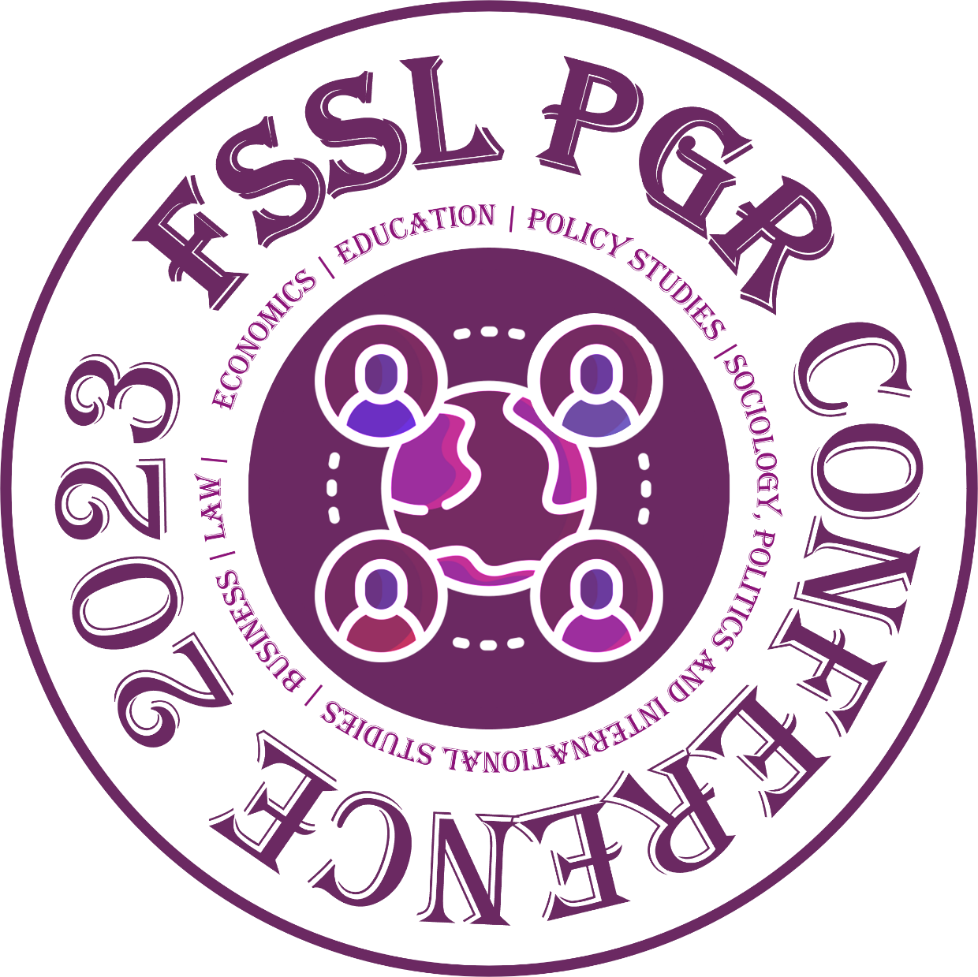
For our conference, we've prioritized locally sourced food for our catering. This helps support local businesses and reduces the carbon footprint associated with transporting food over long distances. All the tableware provided at the conference is biodegradable or recyclable, ensuring minimal environmental impact after the event.
We're striving for a low-carbon conference, avoiding unnecessary printouts, and promoting digital materials instead. This not only reduces paper waste but also helps preserve our forests and reduce energy consumption associated with producing paper products.
In line with our commitment to reducing carbon emissions, our organizing team travels either by public transportation or walks when in Bristol. By choosing sustainable transportation methods, we are helping to reduce the emission of greenhouse gases and improve air quality.

What You Can Do
We invite all participants to join us in our sustainability efforts. Here's how you can contribute:
- Minimize Food Wastage: Be mindful of portion sizes at our catering stations and take only what you can consume. Remember, food waste contributes to greenhouse gases.
- Waste Sorting: Please ensure all waste is correctly sorted into the appropriate bins provided. This aids in effective recycling and minimizes landfill waste.
- Sustainable Transportation: Whenever possible, use public transport, walk, or cycle. This small step makes a big difference in our shared goal of reducing carbon emissions.
Together, we can make the 3rd Annual FSSL PGR Conference a beacon of sustainability and a model for future PGR conferences. Let's work towards a greener, more sustainable future.
Thank you for your support and cooperation!

Sponsor/Partner Acknowledgements
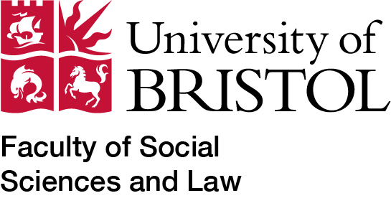
Many thanks to the Faculty of Social Sciences and Law of the University of Bristol for supporting the conference.
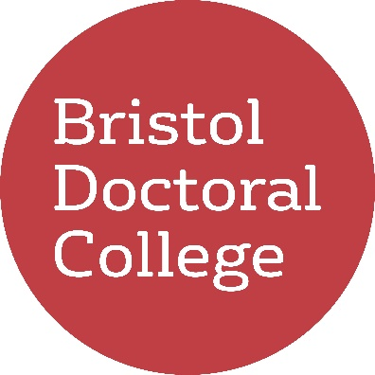

Many thanks to the Bristol Doctoral College
for funding the cross-disciplinary panel
‘Our Common Future’.

GUIDELINES FOR ATTENDEES
These guidelines are for all conference participants to establish expectations. To promote an inclusive and supportive atmosphere among conference participants and audience members, we encourage you to:
- Be kind and provide constructive feedback
- Be open-minded and listen actively
- Put your phone on silent mode
- Meet new people and make new connections
- Ask questions that are encouraging and supportive

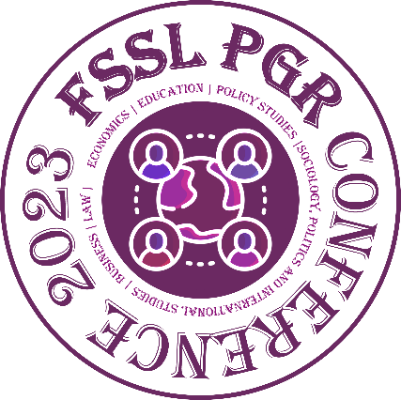

Design and Layout by:
Shang Wu, Shan Lu and Yirong Han

Text by:
Antonia Voigt, Deepti R Bhat, Ruizhe Zhang, Professor Jutta Weldes and Wing-Fu Lai

